380 DISTRICT-SUBSIDIZED CHILD CARE SERVICES

380.1 A family residing in the District of Columbia may be eligible to receive part-time or full-time child care services, subsidized in whole or in part by the District of Columbia. Eligibility to participate in the child care subsidy program shall be determined pursuant to this section.

380.2 A family with an income equal to or less than two hundred fifty percent (250%) of the federal poverty guidelines or eighty five percent (85%) of the District of Columbia median income, whichever is lower, shall be eligible to participate in the District of Columbia child care subsidy program. Actual participation in the program will depend upon the availability of child care slots and the availability of sufficient funding for the District’s subsidies.

380.3 A family participating in the child care subsidy program shall pay a co-payment, based on a sliding fee scale, for the child care services.

380.4 A family with an income equal to or less than fifty percent (50%) of the federal poverty guidelines shall not be required to pay any co-payment.

380.5 A family with an income greater than fifty percent (50%), but less than or equal to (250%), of the federal poverty guidelines shall be required to pay the co-payment amount(s) set forth in section 380.11.

380.6 A family receiving subsidized child care services on October 1, 2009, with an income equal to or below three hundred percent (300%) of the federal poverty guidelines or eighty five percent (85%) of the District of Columbia median income, whichever is lower, shall continue to be eligible to participate in the District of Columbia child care subsidy program if:

- Each parent living in the same household with a child or children enrolled in subsidized child care, must either be employed or participating in a qualifying program in conformance with federal guidelines for subsidized child care during child care hours;

- The family continues to reside in the District of Columbia;

- The family maintains eligibility status with timely submission of appropriate documentation as may be required annually or upon request; and

- The child or children maintain routine attendance at the child development facility or license-exempt relative or in-home caregiver receiving child care subsidy payments.

380.7 In determining the income of a family and the eligibility of the family to participate in the child care subsidy program, a family with a child with medical disabilities or special health care needs may deduct from its income all medical expenses related to that child, if the medical expenses are:

(a) Performed by a licensed health care practitioner; and

(b) Substantiated with payment statements, payment receipts, or
insurance statements identifying the health care service.

380.8 The co-payment requirements in this chapter shall apply only to the first two (2) children in the family.

380.9 There shall be no co-payment requirement for the third child or any additional children of a family.

380.10 Parents shall be responsible for paying co-payments directly to the authorized care provider, including a child care facility, relative care or in-home care provider.

  - The following schedule of co-payments shall apply to services provided by a child
development facility or license-exempt relative or in-home caregiver providing child care services subsidized by the District of Columbia:

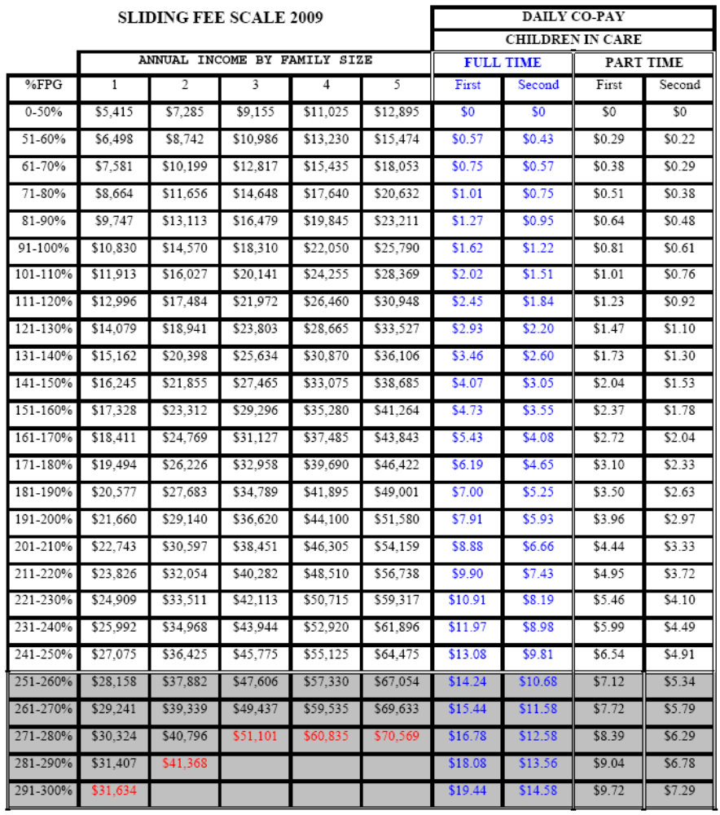

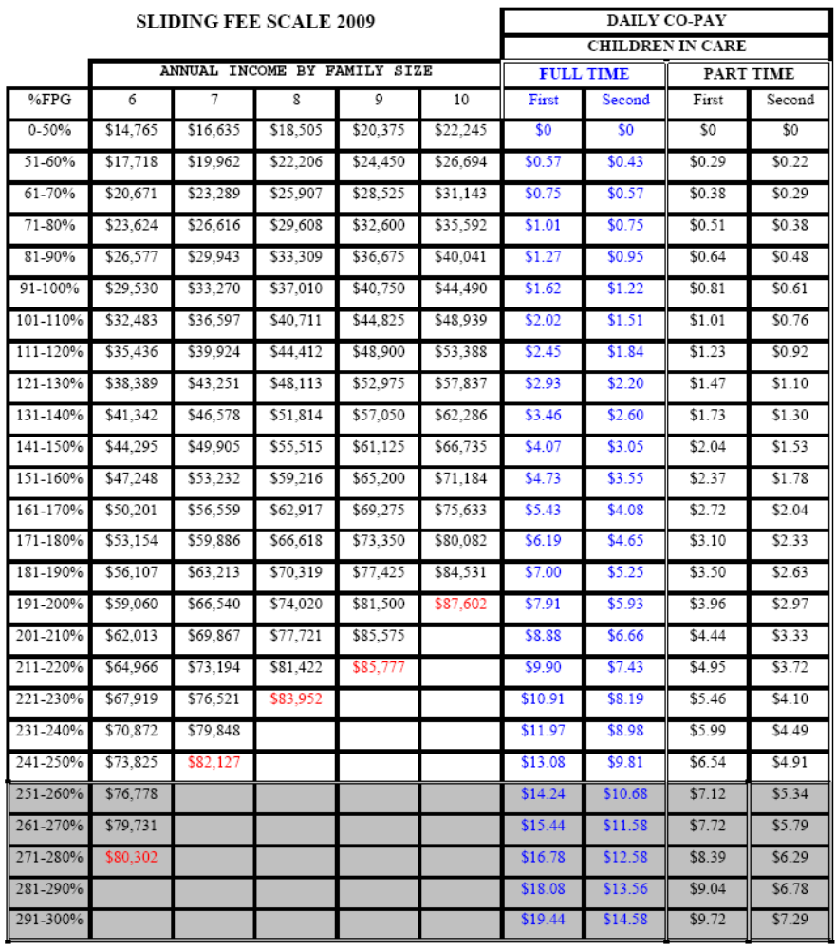

380.12 The schedule of co-payments may be revised periodically.

380.13 For the purposes of this section, the following terms shall have the meaning ascribed:

Child - an individual from birth through the age of twelve (12) years (or up to the age of 19 years if the child has special needs).

Family - a unit consisting of one or more adults and children related by blood, marriage, adoption, or legal guardianship who reside in the same household.

Federal poverty guidelines - means the federal “2009 Poverty Guidelines for the 48 Contiguous States and the District of Columbia”, as published in the Federal Register on January 23, 2009 (74 Fed. Reg. 4199)

Income - the combined total adjusted gross income of the parent(s) with primary responsibility for the child, declared in the joint and/or individual annual federal income tax filing for the most recent calendar year; or in the event such filing is not required with the federal government, other appropriate documentation to establish the total annual income of the parent(s). Examples of income sources include, but are not limited to revenues from: wages, salaries, tips, partnership income, interest, dividends, capital gains, fringe benefits, IRA distributions, pensions, annuities, royalties, trusts, rental income, S corporations, farm income, alimony, child support, Social Security, unemployment compensation, and disability compensation.

Residence - the location where the parent(s) with primary responsibility for the child resides and claims as the permanent place of residence for purposes of one or more of the following: federal and state taxes; receipt of public financial support; voter registration; driver registration; valid residential lease; or other criteria that establishes the District of Columbia as the person’s domicile.

SOURCE: Final Rulemaking published at 57 DCR 984 (January 22, 2010).

